RT200: Upper Extremity Evaluation

INSTRUCTIONS:

The objective of this upper extremity assessment is to determine if the patient is appropriate for safe use of the upper extremity portion of RT200 Hybrid FES elliptical.
Below are:

A. A brief overview of what the RT200’s electrical stimulation is doing and how the RT200 operates in general with upper extremities. The default parameters utilized by the RT200 are provided (although there is much flexibility in parameters) as these may be a good starting point for trial of FES with another device to determine responsiveness.
B. Details related to responsiveness to stimulation are very important to determining patient’s appropriateness for upper extremity use during on the RT200. Below is a guide to recommended electrode placement options.
C. A series of questions related to range of motion, response to electrical stimulation, physical positioning and patient presentation are listed below in order to determine appropriateness. Please provide as much detail as possible in answering the questions. Photos can be helpful as well.
If you have any questions in completing the following questions please feel free to contact Restorative Therapies clinical support at 1-800-609-9166 x343.

A. OVERVIEW
Each RT200 session starts passive ‘warm-up’ (motor powered) and stimulation may be enabled for selected constant on channels during this time. This is designed to reduce any tone or spasticity and get the body in motion before the application of the stimulation. The next phase is the active transition; this is where an increasing level of stimulation is applied to target muscle groups.. Note the RT200 FES therapy system has the capability to designated ‘always on’ channels, this enables the stimulation to initiate and ramp up to a therapeutic level. After the active cycling time the system then goes into a passive cool down.
Once the optimum ‘always on’ stimulation level is reached the system will begin to move, initiating the start of the warm up phase. Once the warm up is completed, the muscle specific stimulation will initiate and the ‘active’ phase of the therapy session begins. After completion of the active phase of the therapy the stimulation turns off and the ‘cool-down’ (back to motor powered) begins.
For bilateral arm therapy the default stimulated muscle groups are:
a. Crank angle coordinated stimulation to the biceps, triceps.
b. ‘Always on’ stimulation to the shoulders, scapula, or postural musculature. Please note patient’s with shoulder subluxation may not be appropriate for use of the RT200 and may benefit from the support provided on the RT300 UE ergometer.
Default parameters for an upper extremity therapy includes a 40Hz frequency, 250usec pulse width and intensity as tolerated to obtain a muscle contraction. There is much flexibility in parameter adjustment on the RT200 but this may be a good starting point if testing with a handheld FES unit.

You can see an example of the RT200 in use at: www.restorative-therapies.com
Please select products and then either the RT200-SLSA or the RT200-SA.

B. ELECTRODE PLACEMENT
Figure 1. Deltoids/Infraspinatus (subluxation correction):
*Note you may also reduce subluxation by stimulation of deltoids alone by placing electrodes on anterior and posterior deltoid without involving rotator cuff musculature if needed.
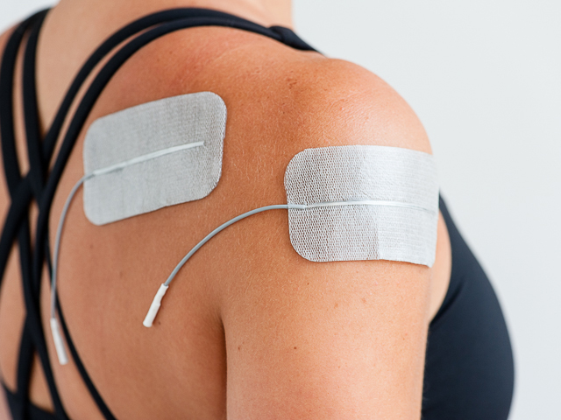

Figure 2: Shows placement for rhomboids with Lower trapezius/latisimus dorsi electrode placement, which is a good option for correction of scapular winging, stabilization of/or scapular postural corrections.

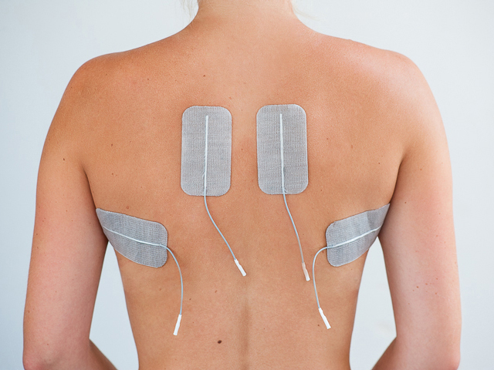

Figure 2 & 3. Erector Spinae for trunk extension/postural correction
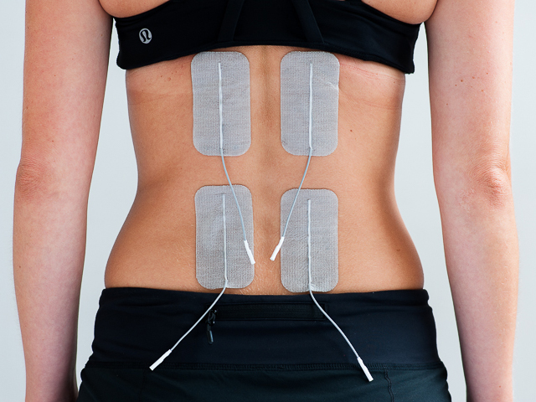

Figure 4: Bicep and finger flexor placements:
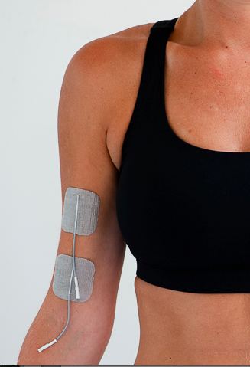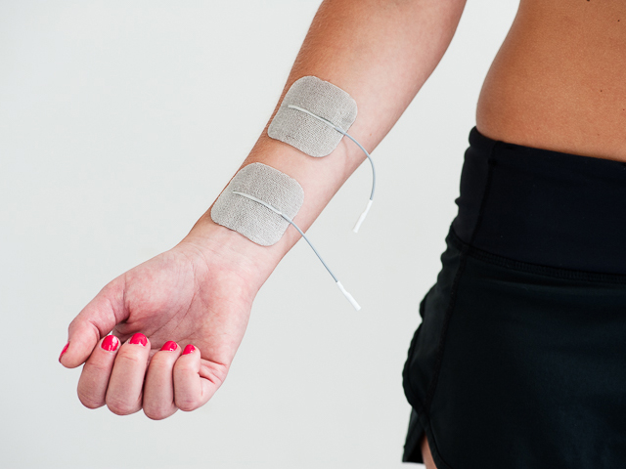

Figure 5: Tricep and wrist/finger extensors placements:

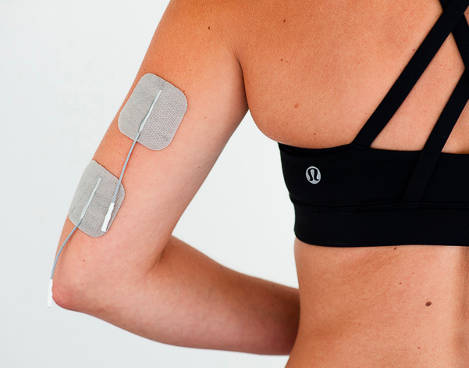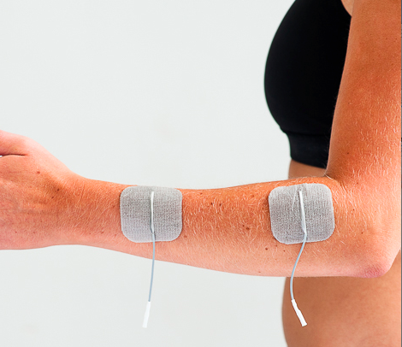

C. UPPER EXTREMITY ASSESSMENT
1. What is the patient’s diagnosis? Are there any issues related to the patient, diagnosis or upper extremity exercise that are of concern? (Cognition, ability to reliably communicate, deformity etc.)

2. What muscle groups of the bilateral upper extremities exhibit MMT grades of 3/5 or
below? (i.e. What are the greatest areas of weakness, note the system has the
option for up to 16 channels of stimulation)

3. What is the available pain free passive range of motion (PROM) at the following joints: (Please note if the patient has AROM, or if contractures are present)

LEFT |  |  | RIGHT
 |  | Shoulder flexion
 |  | Shoulder extension
 |  | Shoulder abduction
 |  | Elbow flexion
 |  | Elbow extension
 |  | Forearm pronation
 |  | Forearm supination
 |  | Wrist flexion
 |  | Wrist extension
 |  | Digit MCP flexion
 |  | Digit MCP extension
 |  | Digit PIP flexion
 |  | Digit PIP extension
Please note any limitations:

4. Does the patient exhibit any GH joint shoulder subluxation? Bilaterally or unilaterally
and to what degree?

5. With FES applied a shown in photos above for subluxation correction does the
patient’s subluxation correct with stimulation? Does it fatigue rapidly or is it sustained
with FES application for a period of time?

6. Related to question 2, please test any weak muscle groups with FES and note
responsiveness in each group. If no response is noted in a specific muscle group
please document the stimulation parameters utilized, as this could be an area of
severe muscle disuse atrophy or lower motor neuron damage. Please also note
electrode size used for each muscle.

Please note that this assessment is not complete without an FES trial.

7. How long is the patient able to tolerate sitting up in a 80-90 degree position?

8. Are there any other issues or concerns we should be aware of related to patient’s ability to tolerate this type of physical activity?

__________________________________________ _______________________
Evaluator’s name & discipline Date

___________________________________________ ________________________
Evaluator’s facility Contact number

