Replacing RT600 toe straps
The RT600 toe straps will need to be periodically replaced when they show signs of wear or if the hook and loop is no longer effective.
Restorative Therapies part numbers are shown in Table 1.
Footplate size | Top strap (has hooks attached) | Bottom strap
4 | PP214610A | PP214610B
3 | PP214611A | PP214611B
2 | PP214612A | PP214612B
1 | PP214613A | PP214613B
Table 1 Toe strap part numbers
Follow the procedure detailed below:
1. Remove both side of the old toe strap from the footplate
2. Fit both sides of the new toe strap
- Thread the strap fully through the bottom slot. If it is a "top" strap ensure that the securing hooks are facing upwards
- Loop the strap back through the top slot in the footplate and the plastic D ring on the strap
- Pull the strap fully through
- Repeat on the other side of the footplate

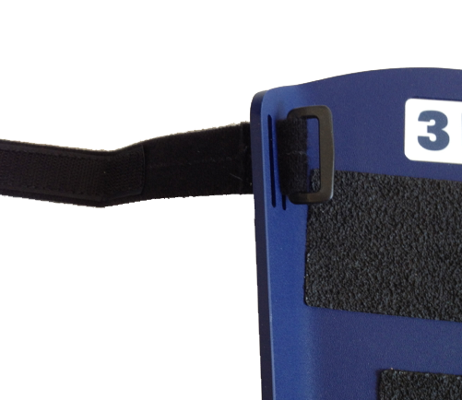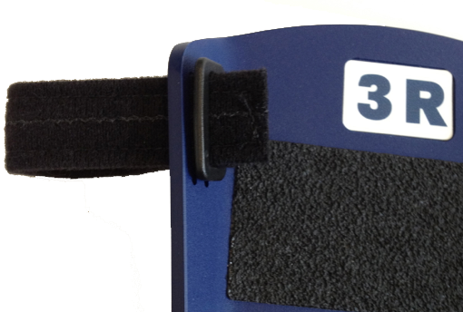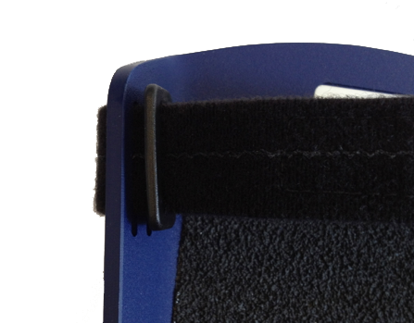
Figure 1 Fitting a toe strap

