Restorative Therapies RTILink Database & System IT Information

RTILink Overview
RTILink is a database that resides on a server at www.RTILink.com (IP address: 69.89.6.226).

The purpose of RTILink is to:

- download patient therapy parameter data to the control unit interface (the controller for the device / ergometer)
- upload patient therapy result data from the control unit interface
- download automatic software updates to the control unit interface

RTILink is compliant with the HIPAA security rule.

Patients are identified by a seven-digit ID number including a 1-digit checksum) that is created when a new patient record is created in RTILink by a clinician. Only the clinician is able to match this RTILink ID with their actual patient.

System Interface Overview – The Device
The system interface for the device is a control unit, a tablet PC running Windows 10. The control unit is configured to run Restorative Therapies' proprietary software application upon startup which is hardcoded to only connect to RTILink or restorative-therapies.com. Users are not able to utilize the control unit for other Internet functions from within the application.

RT300 system
RT300 systems use a Microsoft Surface GO. It connects to the Internet via a WiFi network supporting 802.11 a/b/g/n.

The WiFi manager is capable of WEP, WPA, and WPA2 encryption. It can also be configured for a static IP connection, or a proxy server connection. 802.11 and 802.1x authentication methods are also supported using various methods of authentication such as PEAP and EAP.

The MAC address for the WiFi adapter is available from the SAGE software (Help | About).

RT300 system Control Unit Technical Specifications
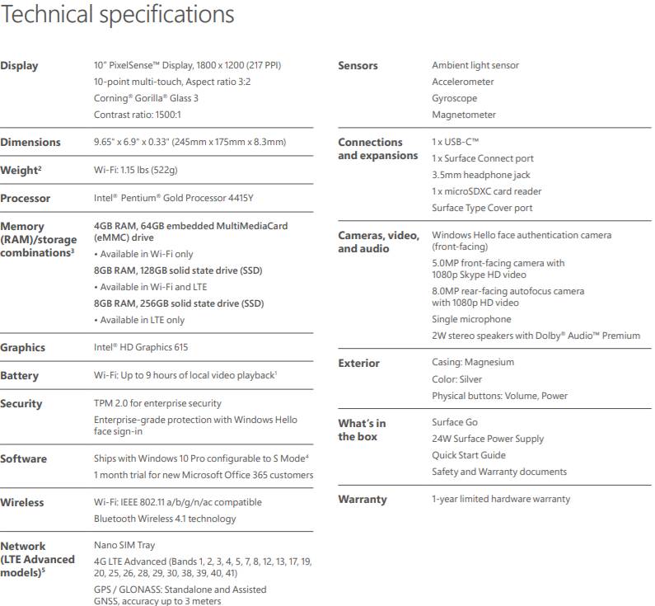

RT200, RT600, Xcite systems
RT200, RT600 and Xcite systems use a tablet pc manufactured by Cybernet Manufacturing, Model T10C. It connects to the Internet via a WiFi network supporting 802.11 a/b/g/n, or a wired LAN connection up to 1Gbps.

The WiFi manager is capable of WEP, WPA, and WPA2 encryption. It can also be configured for a static IP connection, or a proxy server connection. 802.11 and 802.1x authentication methods are also supported using various methods of authentication such as PEAP and EAP.

The MAC address for the WiFi adapter is available from the SAGE software (Help | About).

RT200, RT600, and Xcite systems Control Unit Technical Specifications
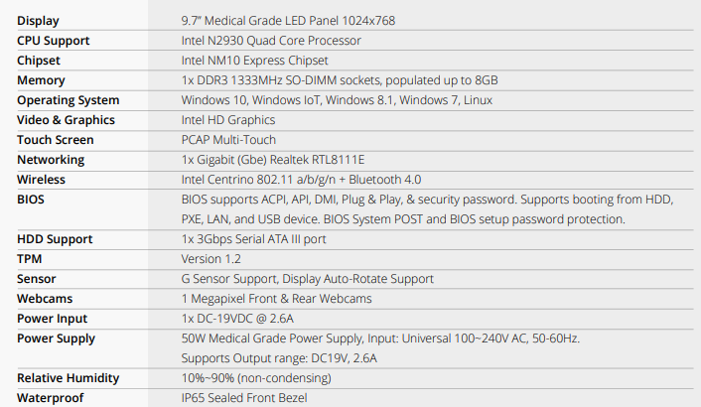

Internet Connection

Overview
- The control unit communicates directly with the RTILink database across the internet – a connection to a facility’s intranet is NOT necessary.
- The communication protocol for transmission of information is HTTPS.
- The control unit initiates all communications with RTILink.com.

Clinicians are able to log on to RTILink using a username and password to add, view or edit patient therapy settings and produce session and progress analysis reports. Two factor authentication using Google Authenticator or Microsoft Authenticator is available. This can be enforced as a clinic setting by the clinic administrator or used by individual clinicians.
The control unit can connect to a wireless network utilizing a hyperlink within the Restorative Therapies application to access the Windows 10 wireless manager. For RT300 systems, a USB-c to ethernet adapter can be used to achieve a hard-wired connection to the RTILink database.

Network Diagram and Data Flow
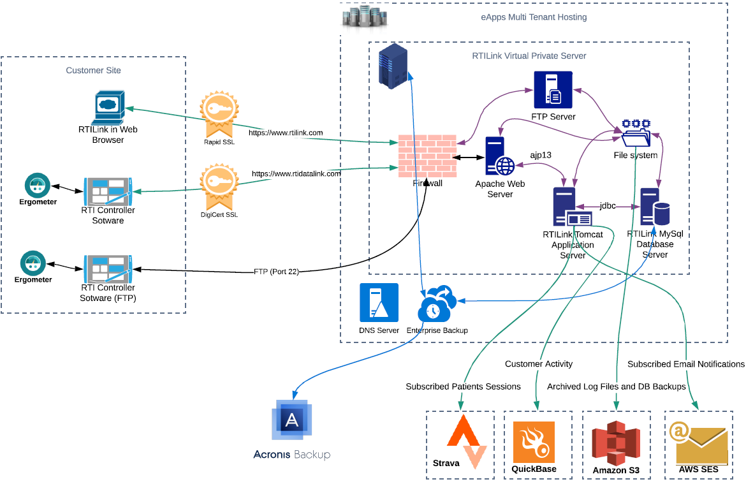

PHI
Below is a list of the 18 PHI identifiers and their status in RTILink.com. Note that RTILink.com provides a setting which can be optionally set for a clinic to prohibit storage of any identifying information (see column 3 in the table below). This provides Safe Harbor de-identification.

# | Identifier | RTILink.com | Can be prohibited
1 | Names | Not stored | N/A
2 | All geographical subdivisions smaller than a State | Not stored | N/A
3 | All elements of dates (except year) for dates directly related to an individual | Birthdate can be entered into patient record | Yes
4 | Phone numbers | Not stored | N/A
5 | Fax numbers | Not stored | N/A
6 | Email addresses | Email address can be entered into patient record. Required if patient is to receive progress Emails. | Yes
7 | Social Security numbers | Not stored | N/A
8 | Medical record numbers | MRNs can be entered into patient records as a means of cross referencing the RTILink.com ID number. | Yes
9 | Health plan beneficiary numbers | Not stored | N/A
10 | Account numbers | Not stored | N/A
11 | Certificate/license numbers | Not stored | N/A
12 | Vehicle identifiers and serial numbers | Not stored | N/A
13 | Device identifiers and serial numbers | Only clinic device identifiers are stored as part of session data. These do not identify a patient. | N/A
14 | Web Universal Resource Locators | Not stored | N/A
15 | Internet Protocol (IP) address numbers | Not stored | N/A
16 | Biometric identifiers | Not stored | N/A
17 | Full face photographic images | Not stored | N/A
18 | Any other unique identifying number, characteristic, or code | Not stored | N/A

Other Data
The following data is also maintained for each patient.

# | Data | Description
1 | ID number | Seven-digit auto generated RTILink ID number (includes checksum) used to identify the patient within RTILink.
2 | PIN number | Four digit PIN used to confirm the ID number when downloading a therapy. This defaults to patient month & year of birth if available (mmyy).
 | Country | Country where the patient is using the system.
 | Last used controller serial number | Serial number of the last system the patient used – in a clinic environment this will be a clinic system.
 | Date privacy acknowledged | The date the patient acknowledged Restorative Therapies’ privacy practices.
 | Month & year born | Used to auto generate the PIN and set pediatric status. Can be prohibited (see item 3 in table above).
 | Weight | Used to calculate MET minutes and for RT600 sessions.
 | Pediatric | Used to set therapy defaults.
 | Condition | Patient’s condition can be selected from a list of conditions.
 | Session efficiency | Used to calculate MET minutes. Set automatically in certain circumstances.
 | Clinic | Clinic patient is attending.
 | Prescribing clinic | Clinic that originally prescribed the system.
 | 2nd prescribing clinic | 2nd clinic that prescribed the system.
 | Clinician | Login of current clinician.
 | 2nd clinician | Login of 2nd clinician.
 | Therapies | Table of therapy data for the patient. Patient can have multiple therapies. History of each therapy is maintained. An example is shown in Appendix B.
 | Therapy results | Table of therapy result data for the patient.  An example is shown in Appendix C.

Manufacturer disclosure statement
See manufacturer disclosure statement for medical device security in Appendix A.

Appendix A
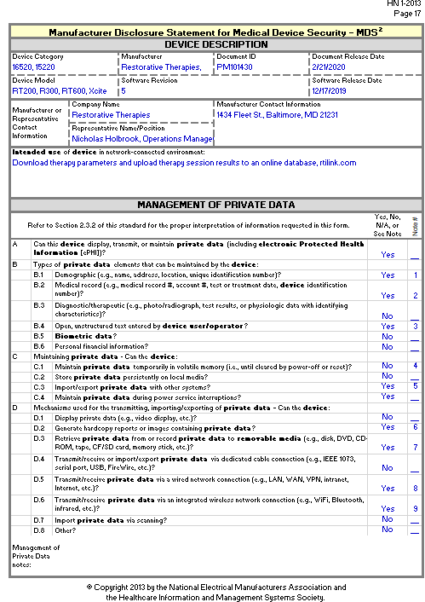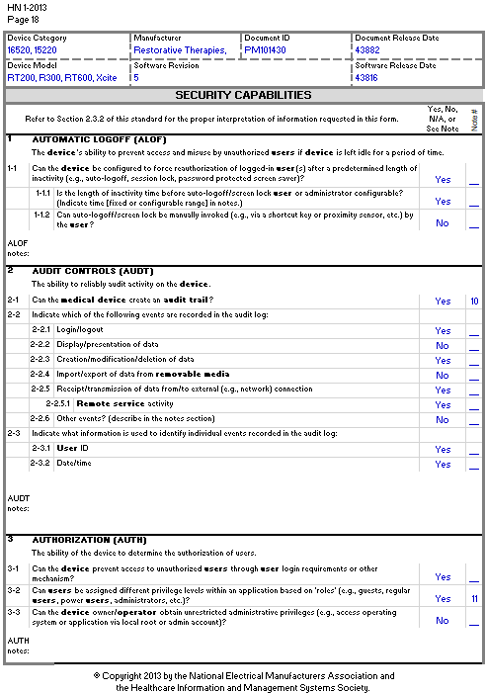
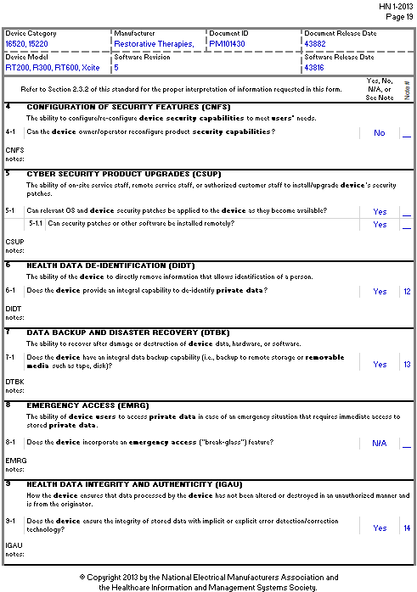
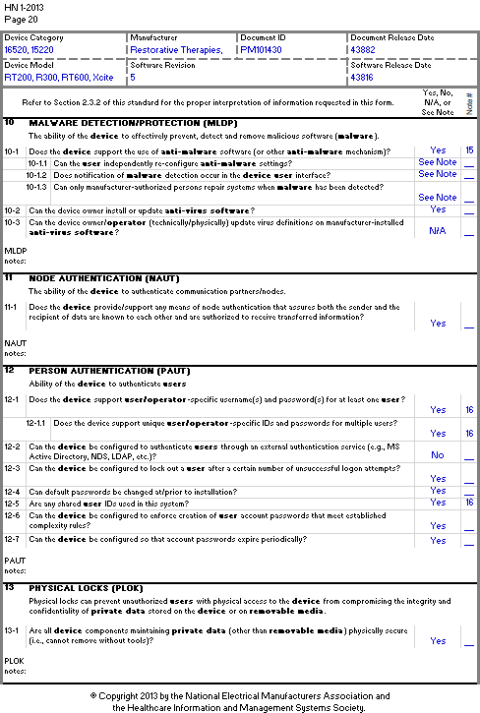
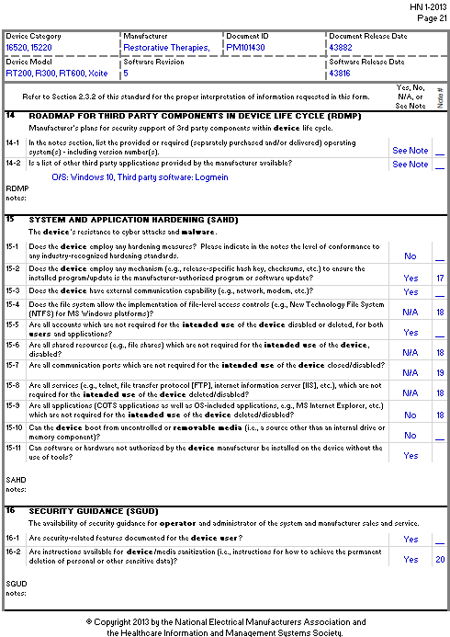
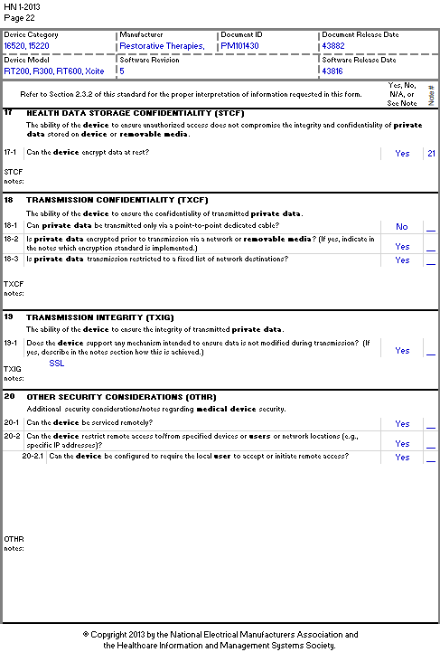
Notes:
1. RTILink.com assigns each patient a unique 7-digit number (includes a checksum)
2. A MRN can be entered as a cross reference. This and all identifying data can be prohibited as an option in the clinic settings.
Session dates are stored. The serial number of the device which the patient used is also stored.
3. The MRN number field is a text field.
4. The device does not store any identifying information. This is only stored in RTILink.com if allowed in clinic settings.
5. RTILink.com can export patient data to xls files or clinic systems if that function is established.
6. RTILink.com can provide printed reports of session data and therapy settings.
7. Recording to removable media in not possible from the device. Recording to removable media is not a function of RTILink.com however it would be possible for a user to save the reports or exported data (see 5 & 6 above) to removable data.
8. The device can connect to RTILink.com via wired network connection using SSL
9. The device can connect to RTILink.com via WiFi network connection using SSL
10. RTILink.com creates an audit trail, the device does not
11. At the clinic level RTILink.com supports users: patients, clinicians, clinic administrators
12. RTILink.com provides a clinic setting which prevents entry of any of the 18 patient identifiers and removes any that have already been entered
13. RTILink.com is continuously backed up. The device is not backed up, but patient therapy setting are uploaded to RTILink.com.
14 Communications between device and RTILink.com has guaranteed data accuracy
15 RTI does not install antivirus software since the device can only connect to RTILink.com. Clinic can optionally install antivirus software on the device
16 The device supports a single clinician login. RTILink.com supports multiple clinician login IDs and passwords.
17 Software updates incorporate checksums.
18 Clinicians have no access to device except via the provided application software
19 All ports on the device are open
20 All identifying information in RTILink.com can be erased via a clinic preference setting
21 Clinic device is encrypted. RTILink.com is encrypted at rest.

Appendix B
Example of therapy parameters shown on RTILink that are downloaded to the RT300 system controller.
7 digit patient ID

Appendix C

Example of therapy results that are uploaded to RTILink from the device controller.

Patient ID |  | Session Date  7 digit patient ID
1000014 |  | 2010-09-22_10-24-17
SESSION DATA
Time(s) | Crank Velocity |  | Motor Velocity | Control/Target Speed |  | Power | Stimulation Level | Drive Torque | Resistance | Pulse |  | Saturation
1 | 0 |  | 0 | 45 |  | 0 | 0 | 9.983 | 0.5 | -1 |  | -1
5 | 0 |  | 0 | 45 |  | 0 | 0 | 9.983 | 0.5 | -1 |  | -1
6 | 3 |  | 5 | 45 |  | 0 | 0 | 9.983 | 2.525 | -1 |  | -1
10 | 6 |  | 6 | 45 |  | 0 | 0 | 9.983 | 2.525 | -1 |  | -1
15 | 12 |  | 13 | 45 |  | 0 | 0 | 9.983 | 2.525 | -1 |  | -1
20 | 17 |  | 20 | 45 |  | 0 | 0 | 9.983 | 2.525 | -1 |  | -1
25 | 22 |  | 26 | 45 |  | 0 | 0 | 9.983 | 2.525 | -1 |  | -1
30 | 29 |  | 33 | 45 |  | 0 | 0 | 9.983 | 2.525 | -1 |  | -1
35 | 35 |  | 40 | 45 |  | 0 | 0 | 9.983 | 2.525 | -1 |  | -1
40 | 36 |  | 40 | 45 |  | 0 | 0 | 9.983 | 0.5 | -1 |  | -1
45 | 40 |  | 40 | 45 |  | 0 | 0 | 9.983 | 0.5 | -1 |  | -1
50 | 41 |  | 40 | 45 |  | 0 | 0 | 9.983 | 0.5 | -1 |  | -1
55 | 37 |  | 40 | 45 |  | 0 | 0 | 9.983 | 2.525 | -1 |  | -1
60 | 37 |  | 40 | 45 |  | 0 | 0 | 9.983 | 2.525 | -1 |  | -1
65 | 37 |  | 40 | 45 |  | 0 | 0 | 9.983 | 2.525 | -1 |  | -1
66 | 37 |  | 45 | 45 |  | 0 | 0.993 | 9.983 | 2.525 | -1 |  | -1

